Dhruv

Millenium Dawn  https://discord.gg/Mks846T

Politics Team

Contents

List of Sub ideologies 2

Definition of Each Sub Ideology 3

Sub Ideology Variable Equivalents 5

An example of how to set party popularities in the NOR – Norway.txt history file. 5

Localizing Sub Ideologies 7

Coalition Governments 8

# 

# List of Sub ideologies

Along with the 5 basic outlooks, there are now 24 sub ideologies. Sub ideologies are locked to one of the 5 Outlooks. The breakdown is as follows

* 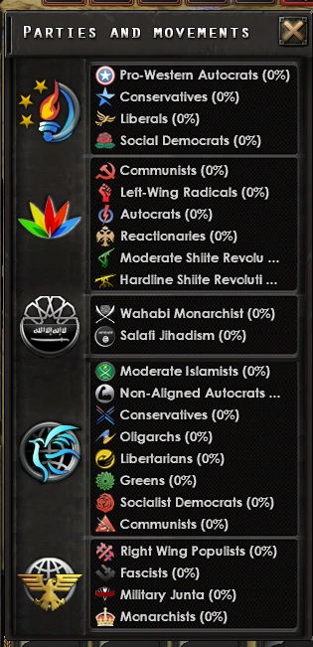Western Outlook
  + Conservative
  + Liberal
  + Social Democrat
  + Pro-Western Autocrat
* Emerging Outlook
  + Communism
  + Reactionary
  + Pro-Emerging Autocrat
  + Hardline Shiite Revolutionary
  + Reformist Shiite Revolutionary
  + Left Wing Radical
* Salafist
  + Salafist Jihadism
  + Wahabi Absolute Monarchy
* Non-Aligned
  + Non-Aligned Conservative
  + Oligarchic
  + Non-Aligned Social Democrat
  + Libertarian
  + Non-Aligned Autocrat
  + Non-Aligned Communism
  + Moderate Islamist
  + Greens
* Nationalist
  + Military Junta
  + Fascism
  + Right Wing Populist
  + Monarchist

# Definition of Each Sub Ideology

**Conservative** - Conservatism refers to a broad spectrum of moderate right-wing ideologies espousing the importance of traditional culture, unity, and a stable way of life. Conservatives tend to oppose state intervention in social and economic affairs, and often believe less regulation will result in greater social mobility for the populace.

**Liberal** - Liberalism is a centrist ideology that promotes the rights of the individual and stresses freedom over the expansion of state power. Liberals tend to support progressive social policies within the framework of a free market with free trade with the rest of the world.

**Social Democracy** - Social democracy refers to a broad spectrum of left-wing ideologies espousing economic and social justice than most branches of liberalism. Social democrats seek to humanize capitalism to curb inequality, oppression, and foster democracy.

**Pro-Western Autocrat** - Pro-western autocracy refers to a broad spectrum of non-democratic, authoritarian ideologies that are aligned with the geopolitical interests of the Western Hemisphere.

**Communism** - Communism broadly refers to an ideology espousing the end of the capitalist system to create a communal worker’s paradise. In reality, communist nations retain capitalistic economic systems and are often non-democratic in nature.

**Reactionary** - Reactionaries refer to a broad spectrum of far-right ideologies whose aims go further than moderate conservatives. Reactionaries typically believe in an idealized version of the past and seek to restore a nation's former glory through revanchist and irredentist ideology and an aggressive military policy.

**Pro-Emerging Autocrat** - Autocracy refers to a broad spectrum of non-democratic, authoritarian political systems where a single ruler or group of privileged elites control all political power.

**Hardline Shiite Revolutionary** - Hardline Shiite revolutionaries refer to a spectrum of far-right and militaristic Shiite adherents who attest to a strict interpretation of Shia Islam. They have largely negative views towards Sunnis and seek to ensure the continuance of Shia Islam within a theocratic state.

**Moderate Shiite Revolutionary** - Moderate Shiite revolutionaries refer to a spectrum of right-wing Shiite adherents who attest to a strict interpretation of Shia Islam but support greater economic and social equality than their more hardline brethren. Despite this, they largely support the continuation of theocracy.

**Left Wing Radical** - Left-wing radicalism is a broad spectrum of far-left ideology that typically espouses the end of capitalism and globalization. While some may support armed resistance, many see themselves as simply ‘more left’ than social democrats and are accepting of liberal democracy.

**Salafist Jihadism** - Salafi jihadism refers to an ultra-strict, ultraconservative and fundamentalist offshoot of Islamic political ideology. They seek to conquer all Islamic lands and rule them through their harsh interpretation of Islamic law. They do not recognize other forms of Islam nor minority religions and will stop at nothing to achieve their goals.

**Wahabi Absolute Monarchy** - Wahhabism refers to an ultraconservative branch of Sunni Islam endorsed by many Gulf State monarchies. Often used interchangeably with Salafism, it is sometimes described as a ‘particular orientation within Salafism.’

**Non-Aligned Conservative** - Conservatism refers to a broad spectrum of moderate right-wing ideologies espousing the importance of traditional culture, unity, and a stable way of life. Conservatives tend to oppose state intervention in social and economic affairs, and often believe less regulation will result in greater social mobility for the populace.

**Oligarchic** - Oligarchy refers to a power structure in which control is placed in the hands of a select group of political and economic elites. Oligarchies are typically non-democratic and authoritarian in nature.

**Non-Aligned Social Democrat** - Socialist democrat ideology refers to left-wing ideologies espousing economic and social justice. While working within the framework of capitalism, they seek heavy redistribution of wealth to curb inequality. They promote the welfare state and to impose more regulation over private business.

**Libertarian** - Libertarianism refers to a broad range of political ideologies and movements espousing liberty as a core principle. Libertarians typically support limited government intervention in all aspects of social, political and economic life than conservatives.

**Non-Aligned Autocrat** - Autocracy refers to a broad spectrum of non-democratic, authoritarian ideologies where all power is placed in the hands of a single ruler.

**Non-Aligned Communism** - Communism broadly refers to an ideology espousing the end of the capitalist system to create a communal worker’s paradise. In reality, communist nations retain capitalistic economic systems and are often non-democratic in nature.

**Moderate Islamist** - Moderate Islamism refers to a broad spectrum of Islamic political movements seeking to establish a democratic state within the confines of Islamic law.

**Greens** - Green politics or ecopolitics refer to a broad spectrum of left-wing movements espousing nonviolence, social justice, direct democracy and environmentalism.

**Military Junta** - Military juntas refer to governments led by a committee of military leaders. Military juntas are often non-democratic and authoritarian in nature and can in a very broad sense be considered a form of military dictatorship or stratocracy.

**Fascism** - Fascism is a form of authoritarian ultra nationalism espoused in militaristic overtones. Fascism seeks to establish a one-party state headed by a single leader wielding absolute authority and supports violence and aggressive expansionism to foster national rejuvenation.

**Right Wing Populist** - Right-wing populism refers to a specific branch of populist ideology that seeks to empower the people against perceived elites that control society. Right-wing populists typically support anti-globalization, protectionism, nativism, nationalism, and an opposition to immigration.

**Monarchist** – they want a monarchy this shit’s not complicated mate

# Sub Ideology Variable Equivalents

Each of the 24 sub ideologies are represented by their own variable the conversion is as follows

|  |  |
| --- | --- |
| Sub-ideology name | Variable name in files |
| Conservative | conservatism |
| Liberal | liberalism |
| Social Democrat | socialism |
| Pro-western Autocrat | Western_Autocracy |
| Communism | Communist-State |
| Reactionary | Conservative |
| Pro-Emerging Autocrat | Autocracy |
| Hardline Shiite Revolutionary | Vilayat_e_Faqih |
| Moderate Shiite Revolutionary | Mod_Vilayat_e_Faqih |
| Left Wing Radical | anarchist_communism |
| Salafist Jihadism | Caliphate |
| Wahabi Absolute Monarchy | Kingdom |
| Non-Aligned Conservative | Neutral_conservatism |
| Oligarchic | oligarchism |
| Non-Aligned Social Democrat | neutral_Social |
| Libertarian | Neutral_Libertarian |
| Non-Aligned Autocrat | Neutral_Autocracy |
| Non-Aligned Communism | Neutral_Communism |
| Moderate Islamist | Neutral_Muslim_Brotherhood |
| Greens | Neutral_Green |
| Military Junta````` | Nat_Autocracy |
| Fascism | Nat_Fascism |
| Right Wing Populist | Nat_Populism |
| Monarchist | Monarchist |

To call the popularity of a party of a country the code is **TAG.partyname_pop**

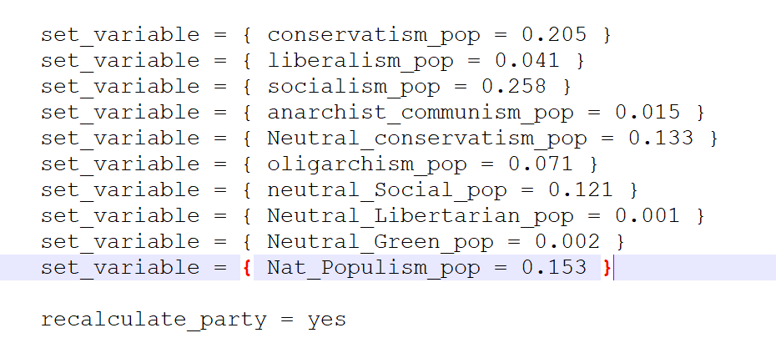The popularity of the sub ideologies must add up to 1 not 100 as each value is stored as a percentage rather than an integer

Anytime the variable values  
are messed with, it must be  
followed by   
**recalculate_party = yes**

### An example of how to set party popularities in the NOR – Norway.txt history file.

When increasing or decreasing the popularity of an outlook, all sub ideologies are proportionally adjusted ex:

add_popularity = {

ideology = fascism

popularity = -0.5

}

recalculate_party = yes

Thus, in this example the Salafist outlook’s party popularity is decreased by 0.5 and thus the Salafi Jihadism sub ideology’s popularity is decreased by 0.025 and the Wahabi Absolute Monarchy sub ideology’s popularity is decreased by 0.025 automatically. Recall that when an outlook’s popularity changes, the other outlooks’ popularity is also affected thereby affecting the popularity of all the other sub ideologues as well. Remember to recalculate party.

When increasing or decreasing the value of a sub ideology, all sub ideologies within that outlook are proportionally affected. Ex:

add_to_variable = {

var = Caliphate

value = 0.05

}

recalculate_party = yes

For this example, the popularity of the Salafi Jihadism sub ideology is increased by 5% and consequently, the Wahabi Absolute Monarchy sub ideology’s popularity is decreased by 5%. Unlike the previous example, the outlook’s popularity remains unchanged and sub ideologies outside the target sub ideology’s outlook remain unchanged. Remember to recalculate party.

# Localizing Sub Ideologies

One of the most immediately visible features with sub ideologies is the usage of text icons to depict the sub ideology’s party logo. All party text icons are placed within the gfx/texticons folder, must be 22x22 pixels, and must be defined in the interface/MD4_texticons.gfx file.

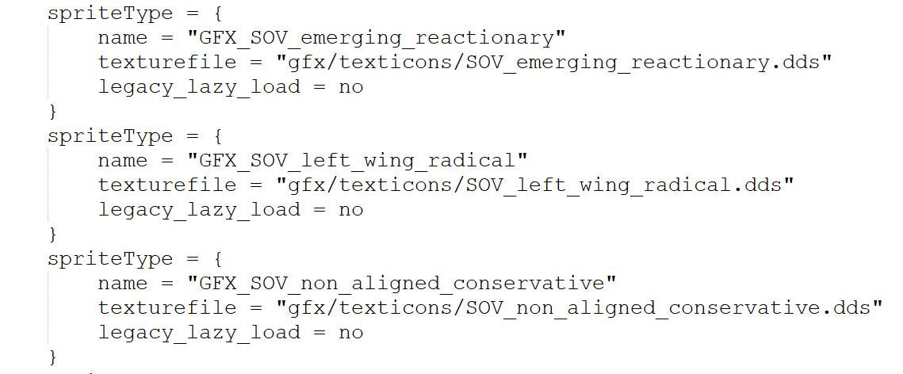

An example on how defining text icons

For nations that do not have preexisting sub ideologies localized already, there is a very good chance that a localization key has not been specified for it. All localization keys for sub ideologies are defined in the common/scripted_localization/subideology_scripted_localisation.txt file. The conventional way to define a localization key is

**text = { trigger = { TAG = TAG } localization_key = TAG.SUBIDEOLOGY }**

and this localization key definition must be placed in the correct **defined_key = {}** code block. The approporiate code block will have the line **name = SUBIDEOLOGY_L** as the first line of the code block.

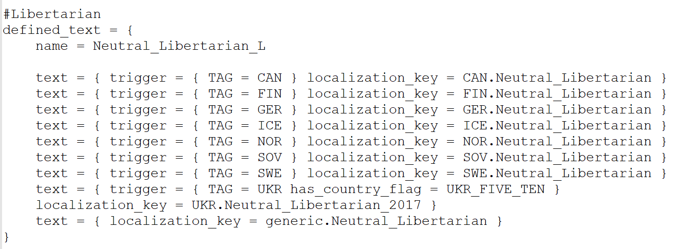

an example on how the Libertarian localization keys are defined

# Coalition Governments

During elections, it’s possible that no sub ideology has a 50%+ majority in which case, a coalition government is formed.